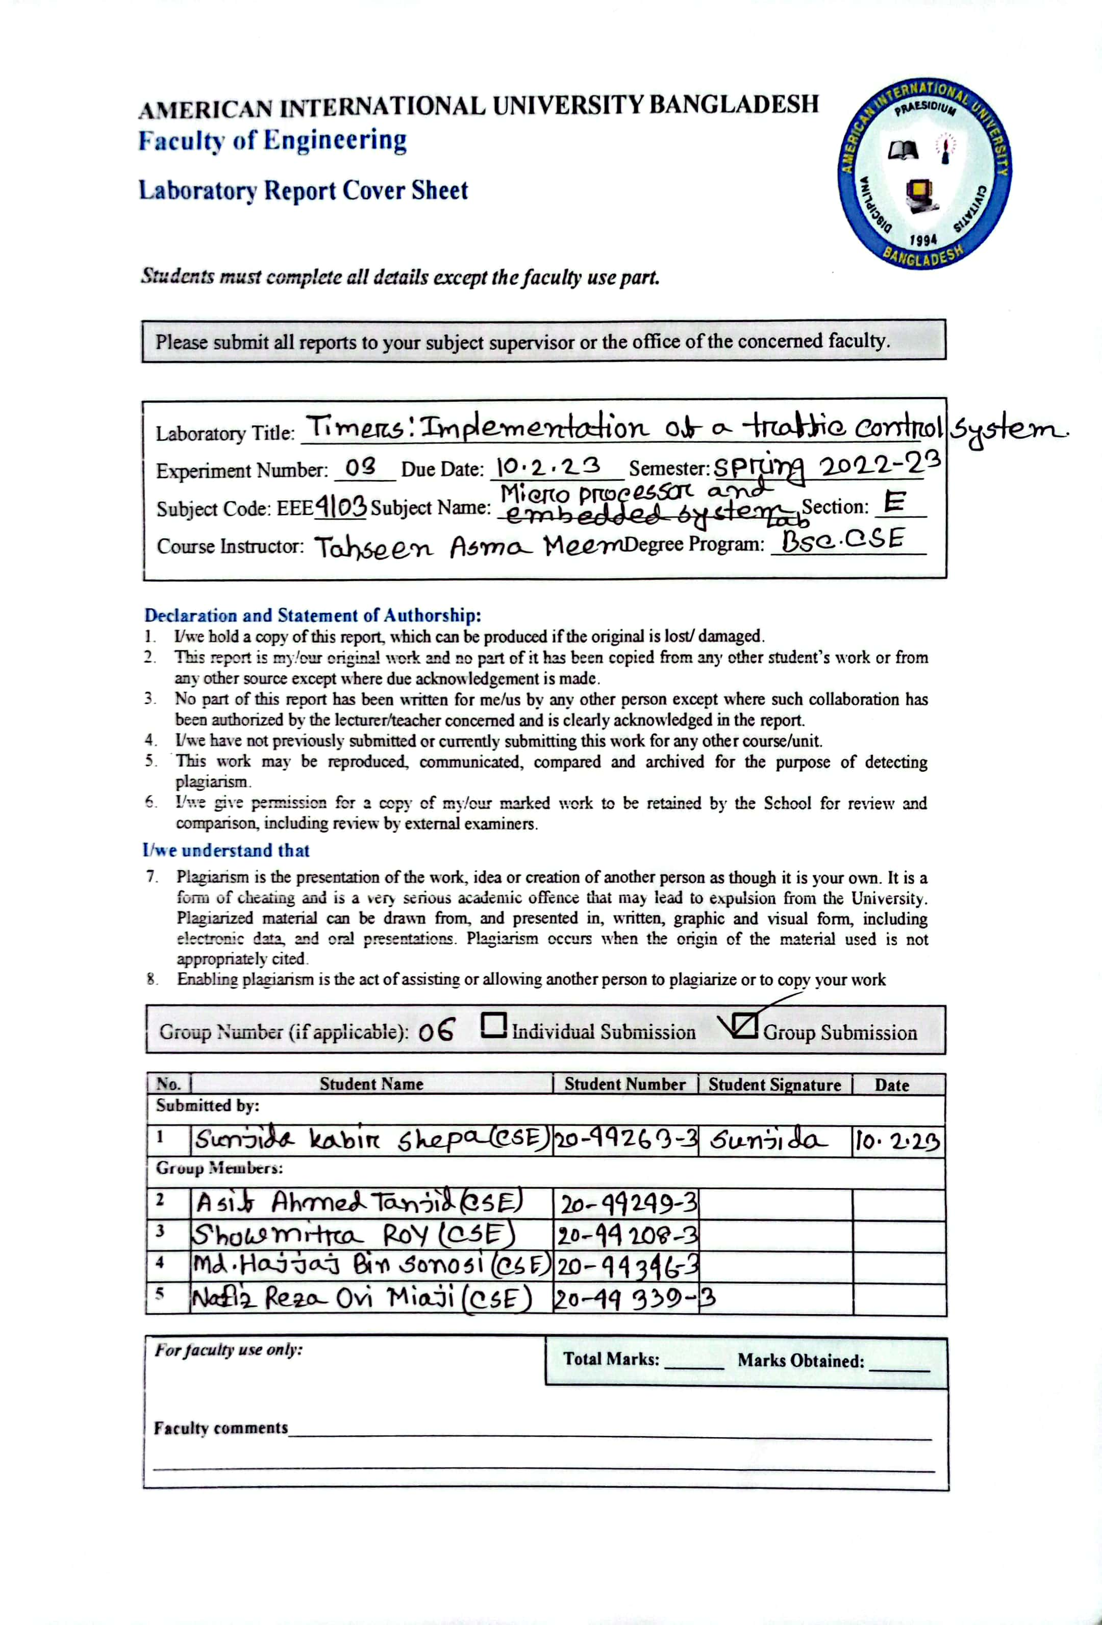

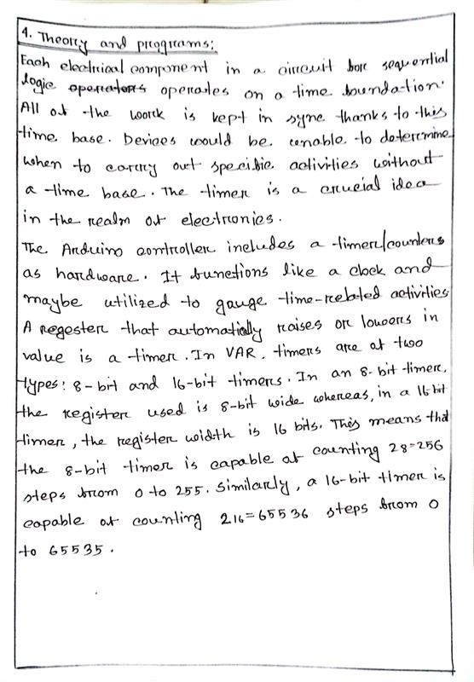

**Source code:**

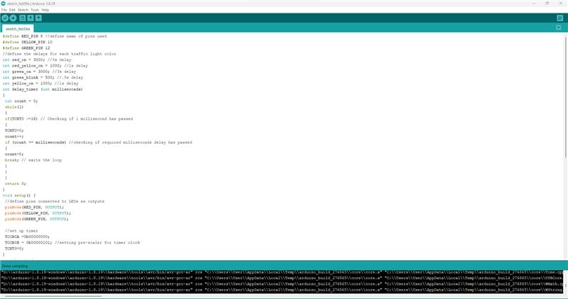

Figure 1.1: Source code for Traffic Control System

Figure 1.2: Source code for Traffic Control System

**Hardware Implementation:**

Figure 2.1: Traffic Control System - Red Light On

Figure 2.2: Traffic Control System – Red and Yellow Light On

Figure 2.3: Traffic Control System - Yellow Light On

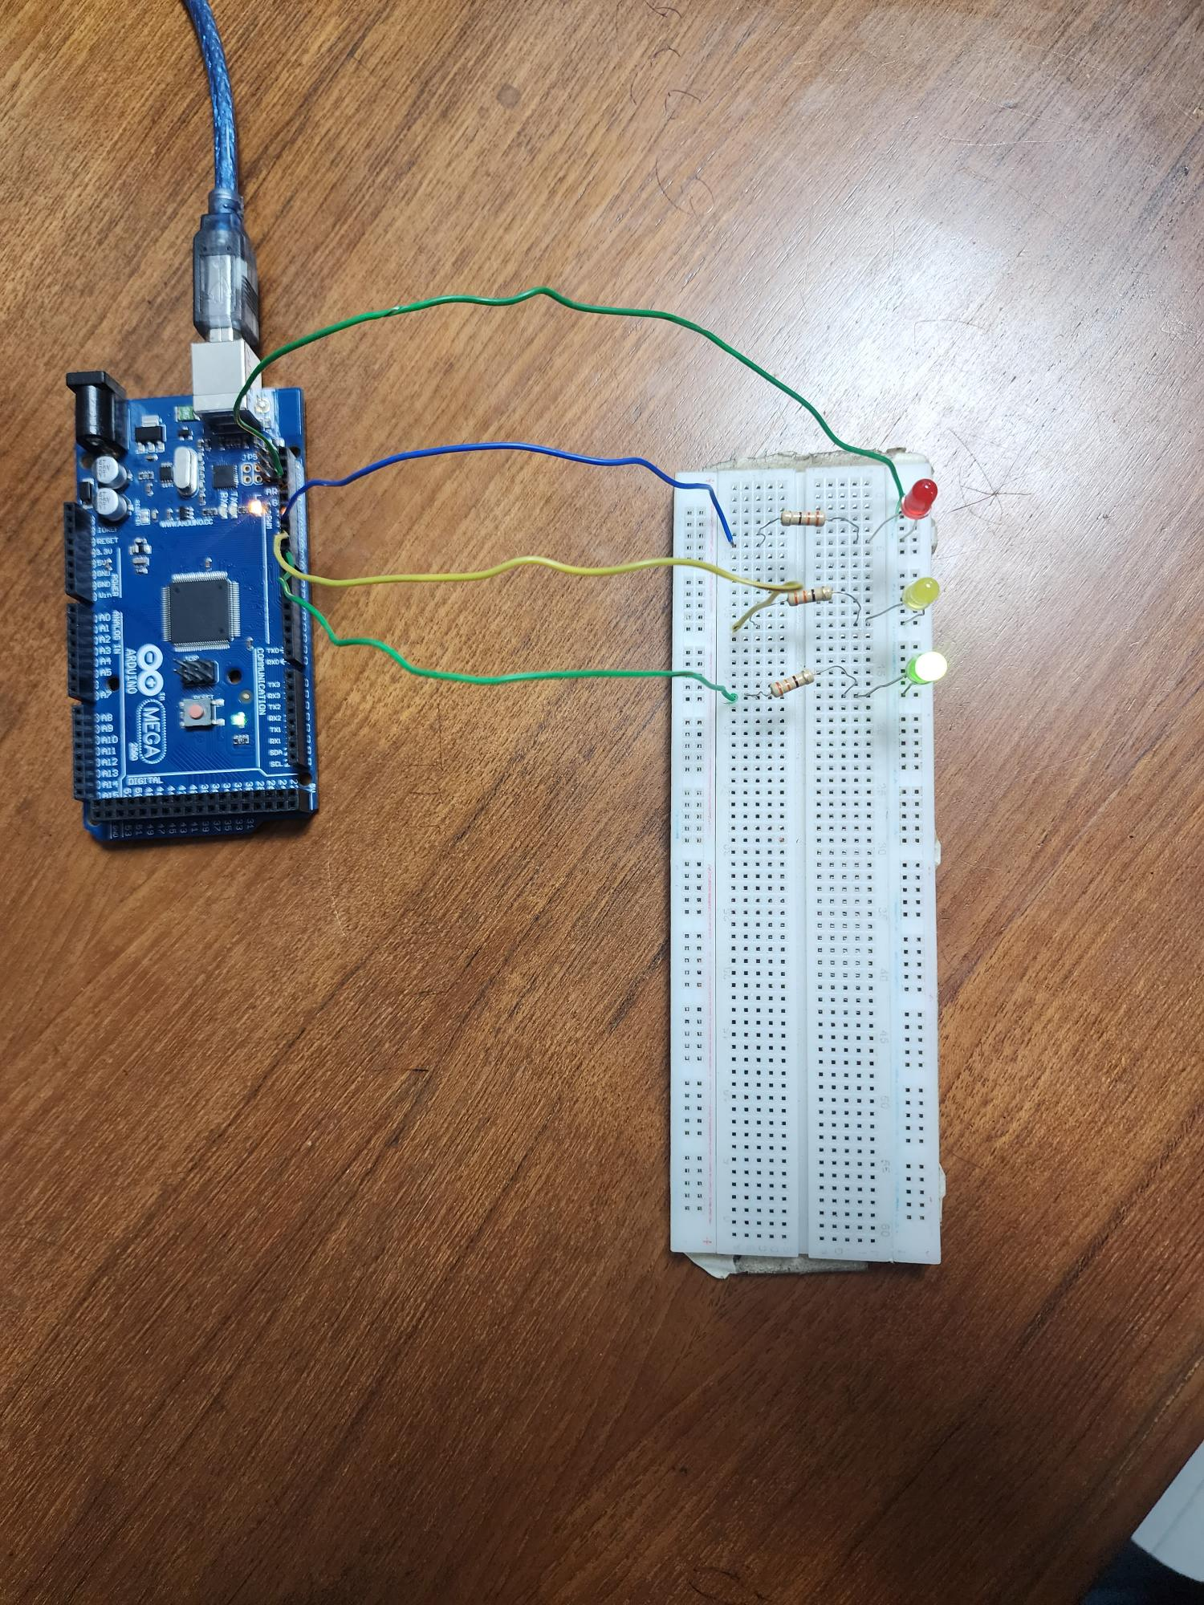

Figure 2.4: Traffic Control System - Green Light On

**Simulation:**

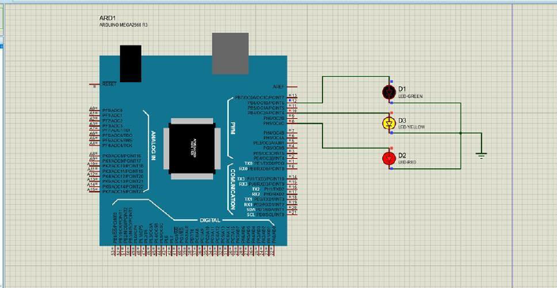

Figure 3.1: Traffic Control System – Red and Yellow Light On

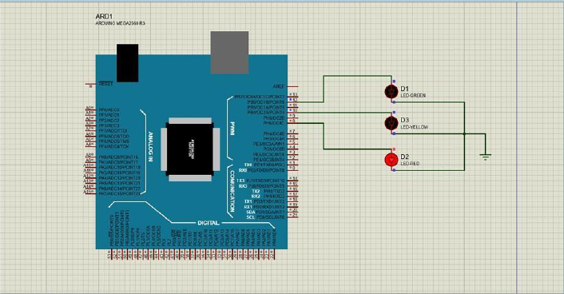

Figure 3.2: Traffic Control System - Red Light On

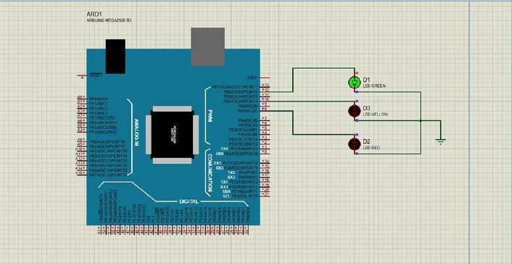

Figure 3.3: Traffic Control System - Green Light On

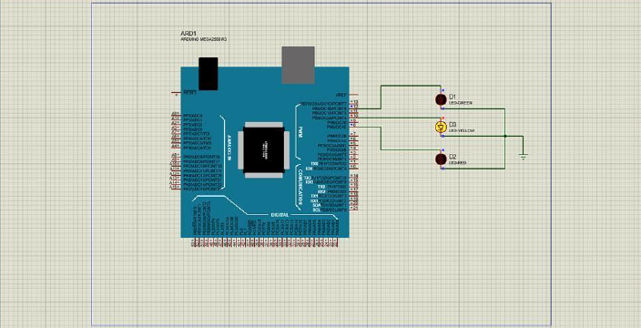

Figure 3.4: Traffic Control System - Yellow Light On

**Report:**

All codes, scripts and proteus simulation of the blink program and traffic light system is attached above.

